CO3 – AT- 2
CASE STUDY REPORT
COURSE NAME: Design and Analysis of Algorithms (DAA)
COURSE CODE: CSA 0603
NAME: S. ALEX MADDY
REG: 192565060

TITLE
Image Processing System (Matrix Multiplication)

An image processing system performs transformations using large matrices. Analyze how divide and conquer matrix multiplication (e.g., Strassen’s method) can improve performance. Identify computational challenges in large matrix operations. Apply the divide and conquer approach to explain optimization. Analyze time complexity and compare with standard multiplication. Design a suitable solution and justify its efficiency.

1. Title
Image Processing System Using Divide and Conquer Matrix Multiplication (Strassen’s Method)

2. Description of the Real-World Problem
Image processing systems perform various operations such as image transformation, filtering, resizing, rotation, feature extraction, and computer vision analysis. Digital images can be represented using matrices, where each element represents the intensity or color information of a pixel. Many image-processing operations require mathematical transformations involving matrices.
For large images, the matrices involved can become very large. Conventional matrix multiplication requires a large number of multiplication and addition operations. As the matrix size increases, the execution time also increases significantly.
For example, multiplying two N × N matrices using the standard method requires N³ multiplications. To improve the performance of such operations, Divide and Conquer matrix multiplication, particularly Strassen’s method, can be used. Strassen’s algorithm divides large matrices into smaller submatrices and reduces the number of recursive multiplications.
This makes it useful for computationally intensive applications where large matrices must be processed repeatedly.

3. Problem Statement
The objective of this case study is to design an efficient matrix multiplication solution for an image processing system using the Divide and Conquer approach.
- Accept two square matrices as input.
- Divide large matrices into smaller submatrices.
- Perform matrix multiplication using Strassen’s algorithm.
- Combine the resulting submatrices to obtain the final matrix.
- Reduce the number of multiplication operations compared with conventional matrix multiplication.
- Analyze the computational complexity and efficiency of the proposed method.

Computational Challenges in Large Matrix Operations
- High computational cost: Standard multiplication requires O(N³) operations.
- Large memory requirements: Large matrices require significant storage.
- Processing time: Execution time increases rapidly as matrix dimensions increase.
- Repeated calculations: Image-processing applications may perform matrix operations many times.
- Scalability: An algorithm that works well for small matrices may become inefficient for very large matrices.

4. Algorithm Used

Strassen’s Matrix Multiplication
Strassen’s algorithm is a Divide and Conquer algorithm for multiplying matrices. Instead of directly performing eight matrix multiplications after dividing two matrices into four submatrices, Strassen’s algorithm performs only seven multiplications.
Consider two matrices:
A = [ A11 A12 ] B = [ B11 B12 ]
[ A21 A22 ] [ B21 B22 ]
Strassen calculates seven intermediate matrices:
M1 = (A11 + A22)(B11 + B22)
M2 = (A21 + A22)B11
M3 = A11(B12 − B22)
M4 = A22(B21 − B11)
M5 = (A11 + A12)B22
M6 = (A21 − A11)(B11 + B12)
M7 = (A12 − A22)(B21 + B22)
The resulting matrix C is:
C = [ C11 C12 ]
[ C21 C22 ]
where:
C11 = M1 + M4 − M5 + M7
C12 = M3 + M5
C21 = M2 + M4
C22 = M1 − M2 + M3 + M6

5. Justification for Choosing the Algorithm (Why This Algorithm?)
- Reduced multiplication operations: Standard divide-and-conquer matrix multiplication requires eight recursive multiplications at every level, whereas Strassen reduces this to seven.
- Better asymptotic complexity: Standard matrix multiplication has O(N³) complexity, while Strassen’s algorithm has O(N^log₂7), approximately O(N².807).
- Suitable for large matrices: The performance improvement becomes more significant as matrix size increases.
- Divide and Conquer strategy: Large matrices are divided into smaller matrices, making the problem easier to solve recursively.
- Useful in image processing: Many image-processing and computer-vision operations involve matrix transformations, so faster matrix multiplication can improve overall processing performance.

6. Complexity Analysis

Standard Matrix Multiplication
For two N × N matrices, each element of the result requires N multiplications. There are N² elements in the result. Therefore, the total number of multiplication operations is N² × N = N³.
Time Complexity: O(N³)
Space Complexity: O(N²) for storing the matrices in a straightforward implementation.

Strassen’s Algorithm
Strassen divides each matrix into four submatrices and performs seven recursive multiplications. Its recurrence relation is:
T(N) = 7T(N/2) + O(N²)
Using the Master Theorem:
T(N) = O(N^log₂7)
Since log₂7 ≈ 2.807:
T(N) = O(N².807)

Complexity Comparison
Matrix Multiplication Method | Time Complexity
Standard Multiplication | O(N³)
Divide and Conquer | O(N³)
Strassen’s Algorithm | O(N².807)
Therefore, Strassen’s method has a lower asymptotic time complexity than standard multiplication.

7. Manual Execution (Step-by-Step Process)
Consider the following two 2 × 2 matrices:
A = [ 1 2 ] B = [ 5 6 ]
[ 3 4 ] [ 7 8 ]
Therefore:
A11 = 1, A12 = 2, A21 = 3, A22 = 4
B11 = 5, B12 = 6, B21 = 7, B22 = 8

Step 1: Calculate M1
M1 = (A11 + A22)(B11 + B22) = (1 + 4)(5 + 8) = 5 × 13 = 65

Step 2: Calculate M2
M2 = (A21 + A22)B11 = (3 + 4)(5) = 7 × 5 = 35

Step 3: Calculate M3
M3 = A11(B12 − B22) = 1(6 − 8) = −2

Step 4: Calculate M4
M4 = A22(B21 − B11) = 4(7 − 5) = 8

Step 5: Calculate M5
M5 = (A11 + A12)B22 = (1 + 2)(8) = 24

Step 6: Calculate M6
M6 = (A21 − A11)(B11 + B12) = (3 − 1)(5 + 6) = 22

Step 7: Calculate M7
M7 = (A12 − A22)(B21 + B22) = (2 − 4)(7 + 8) = −30

Step 8: Calculate C11
C11 = M1 + M4 − M5 + M7 = 65 + 8 − 24 − 30 = 19

Step 9: Calculate C12
C12 = M3 + M5 = −2 + 24 = 22

Step 10: Calculate C21
C21 = M2 + M4 = 35 + 8 = 43

Step 11: Calculate C22
C22 = M1 − M2 + M3 + M6 = 65 − 35 − 2 + 22 = 50
Final Result:
C = [ 19 22 ]
[ 43 50 ]
Thus, the final matrix obtained using Strassen’s algorithm is:
[ 19 22 ]
[ 43 50 ]

8. Applications
- Image Processing – Used in image transformations, filtering, feature extraction, and other mathematical operations involving matrices.
- Computer Vision – Matrix operations are commonly used in image and feature transformations.
- Machine Learning – Large matrix operations are fundamental to many machine-learning computations.
- Scientific Computing – Useful for large numerical calculations and simulations.
- Computer Graphics – Matrix multiplication is used for transformations such as scaling, rotation, and translation.
- Signal Processing – Matrix-based calculations are used in signal transformation and analysis.
- Data Analysis – Large datasets can be represented using matrices and processed through matrix operations.

9. Advantages
- Lower theoretical time complexity than conventional matrix multiplication.
- Reduces the number of recursive multiplications from eight to seven.
- Suitable for large matrices.
- Uses a Divide and Conquer strategy, making the problem easier to break down.
- Can improve performance in computationally intensive applications.
- Can be implemented recursively.
- Useful in applications involving repeated large matrix operations.

10. Limitations
- More complicated implementation compared with standard multiplication.
- Requires additional matrix additions and subtractions.
- Uses additional temporary memory.
- For small matrices, the overhead of Strassen’s algorithm may make it slower than standard multiplication.
- Numerical errors can become more significant when floating-point calculations are involved.
- Handling matrix dimensions that are not powers of two may require padding.
- The theoretical improvement does not always translate directly into better practical performance because of memory and implementation overhead.

11. Comparison with Other Algorithms
Feature | Standard | Divide & Conquer | Strassen
Approach | Direct multiplication | Recursive division | Divide and Conquer
Recursive | No | Yes | Yes
Multiplications per level | N/A | 8 | 7
Time Complexity | O(N³) | O(N³) | O(N².807)
Implementation | Easy | Moderate | More complex
Extra operations | Low | Moderate | Higher additions/subtractions
Small matrices | Very suitable | Suitable | May have overhead
Large matrices | Less efficient | Better structure | More efficient theoretically
Memory requirement | Lower | Moderate | Higher

Overall Comparison
Standard multiplication is preferable for small matrices because of its simplicity and low overhead. For large matrices, Strassen’s algorithm can provide better asymptotic performance by reducing the number of recursive multiplication operations.
Screenshot of the Program
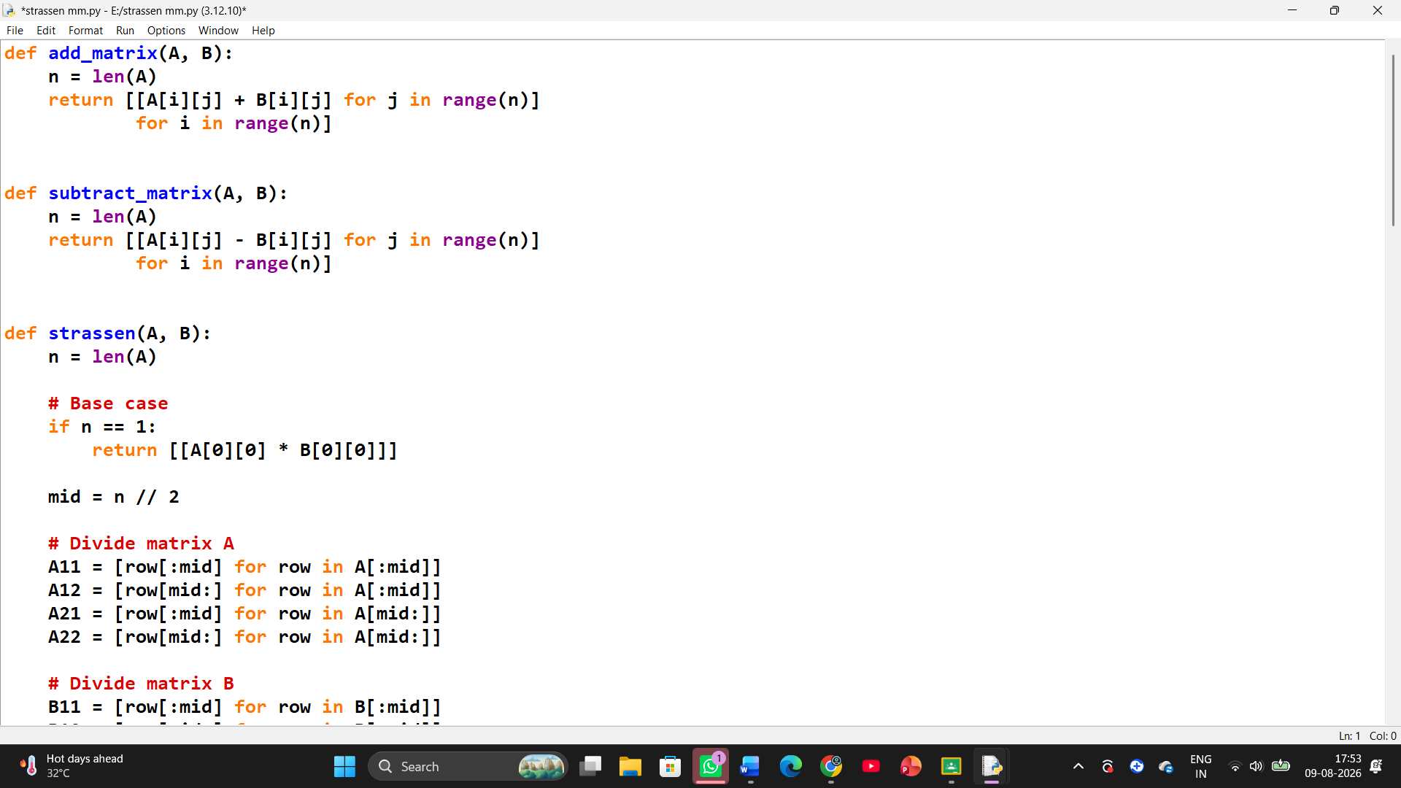
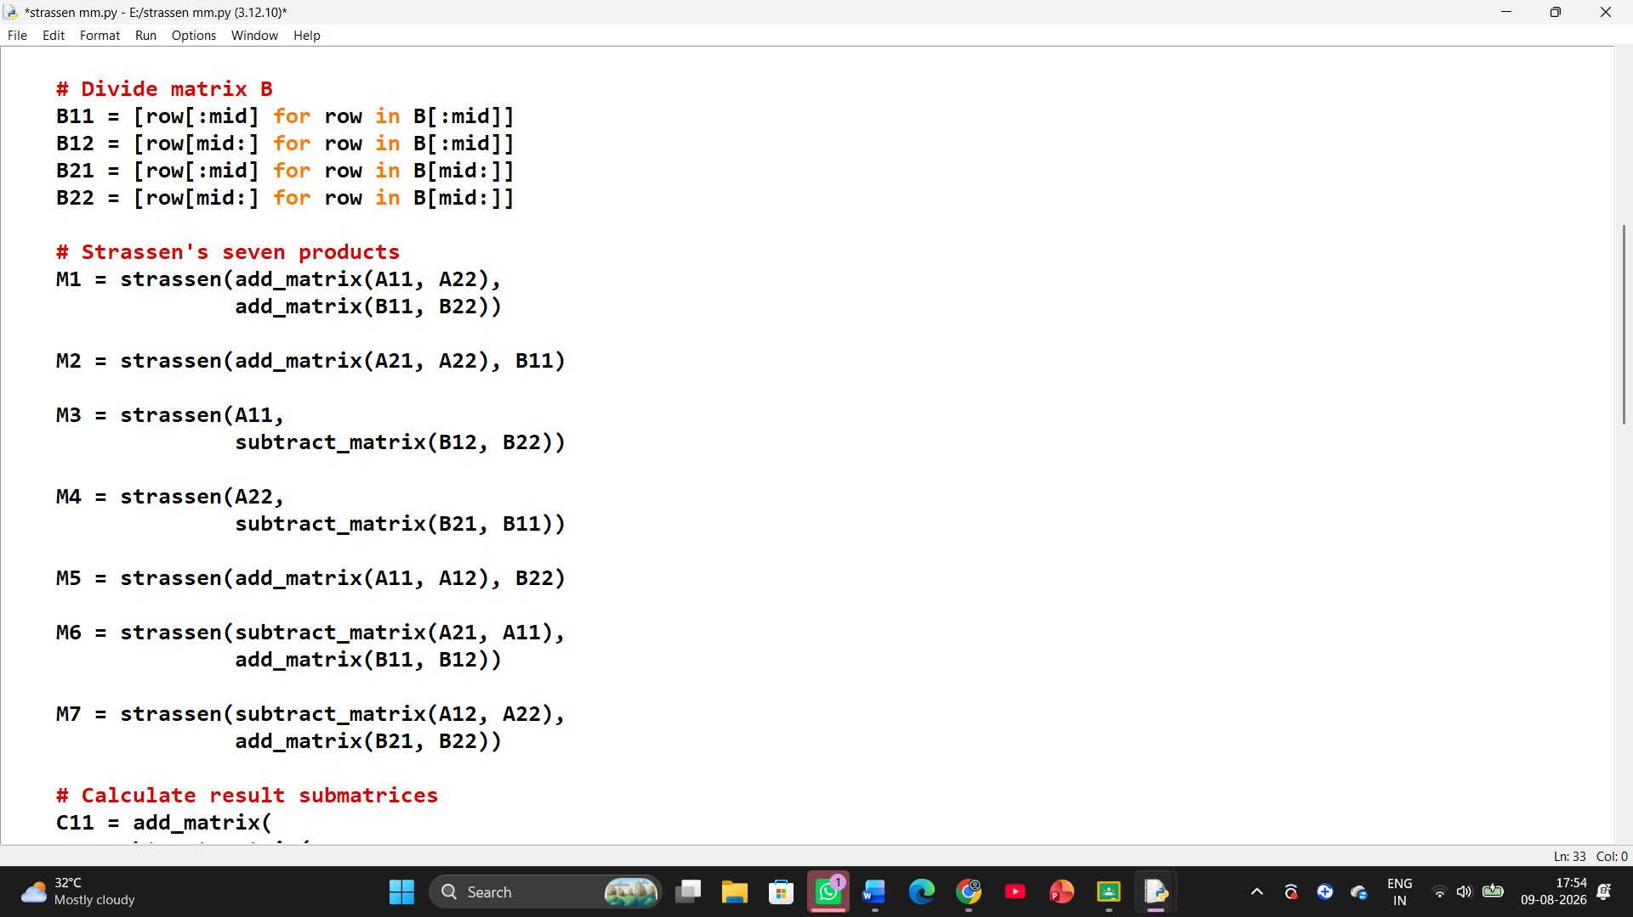

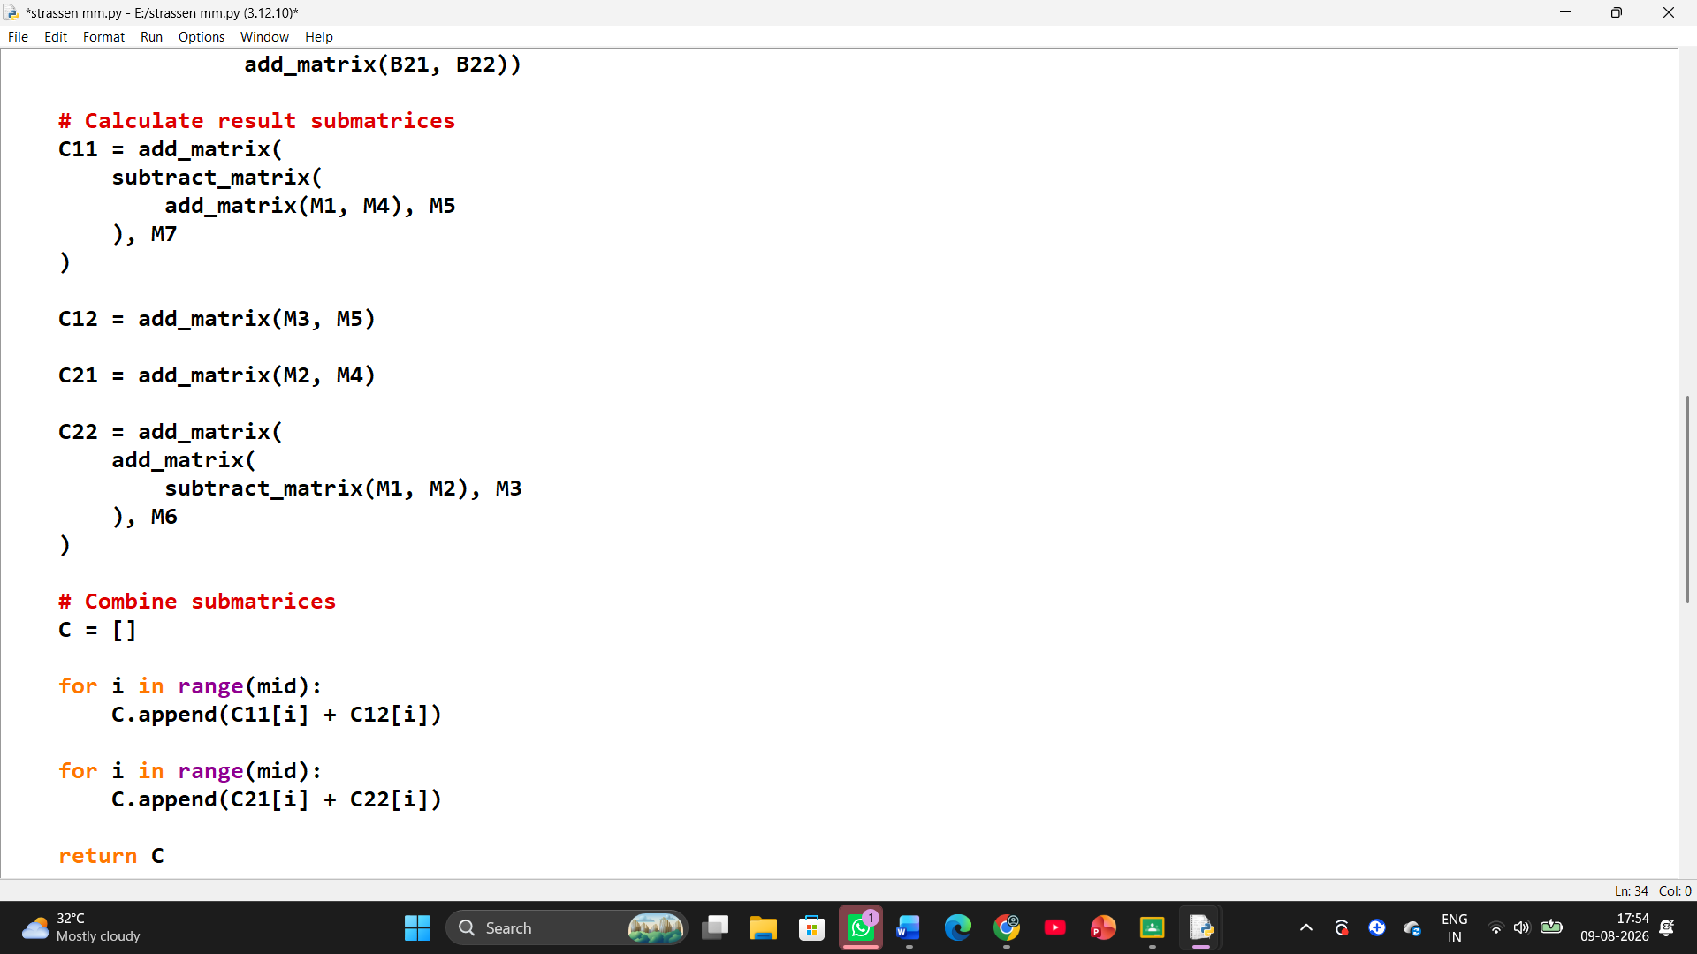
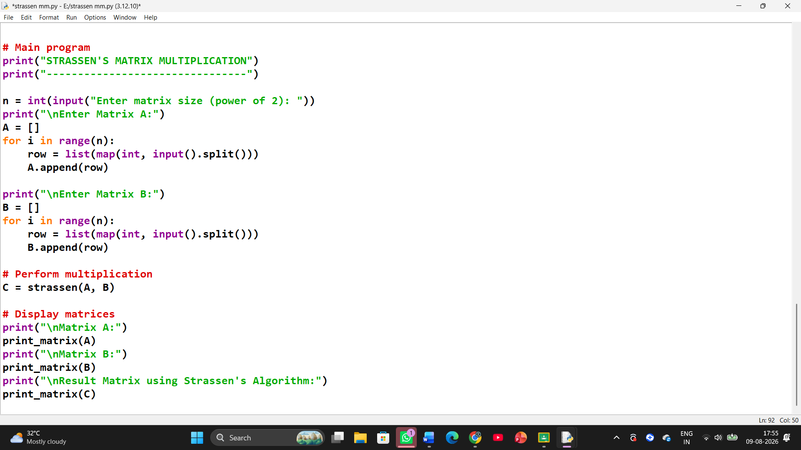

Screenshot of the Output
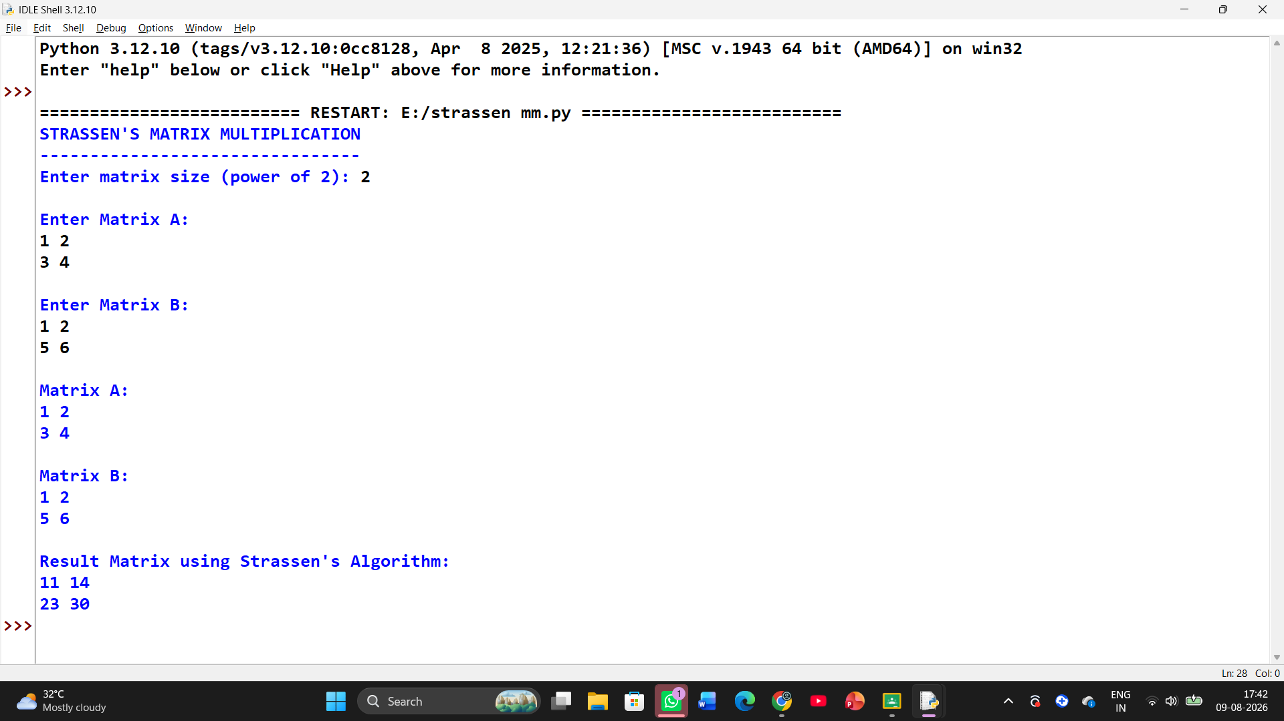

Conclusion
This case study demonstrates how Divide and Conquer matrix multiplication using Strassen’s algorithm can improve the theoretical performance of large matrix operations in an image processing system.
Traditional matrix multiplication has a time complexity of O(N³), whereas Strassen’s algorithm achieves O(N².807) by reducing eight recursive multiplications to seven.
Although Strassen’s algorithm introduces additional additions, subtractions, memory usage, and implementation complexity, its reduced asymptotic complexity makes it a suitable approach for large-scale matrix operations. Therefore, for sufficiently large matrices in image processing and other computational applications, Strassen’s method can provide significant performance benefits.

References
- Thomas H. Cormen, Charles E. Leiserson, Ronald L. Rivest and Clifford Stein, Introduction to Algorithms, MIT Press.
- Ellis Horowitz, Sartaj Sahni and Sanguthevar Rajasekaran, Computer Algorithms.
- Donald E. Knuth, The Art of Computer Programming, Volume 2: Seminumerical Algorithms.
- Thomas H. Cormen et al., Divide-and-Conquer Algorithms and Matrix Multiplication concepts, Introduction to Algorithms.

